Genesis Wins the Battle of the Buildings
Genesis of Ann Arbor was presented a Battle of the Buildings Award for reducing water use by 60.23% (2023 vs 2022). This award was presented to Murray Rosenthal, Chair of the Genesis Green Team, on May 8, 2024, at the Michigan Energy Summit in Grand Rapids. The United States Green Building Council (USGBC) of Michigan announced the eleven winners of this year's Battle of the Buildings contest. Genesis of Ann Arbor has won this year’s award for the “Biggest Loser” in the water savings category. The Genesis building reduced its water consumption by 60.23% in 2023 compared to 2022.

Genesis of Ann Arbor is a unique and equal partnership between St Clare’s Episcopal Church and Temple Beth Emeth. This partnership started 50 years ago. The idea is that the Church uses the building on Sunday and the Temple uses it on Friday evening and Saturday.

There are well over 100,000 buildings in Michigan. And the Genesis building had the biggest loss of water use of all of them. Other awardees included Ford Field, The Huntington Center (the old Cobo Hall) and a building at the University of Michigan Bell Tower, who reduced greenhouse gas emissions. Genesis is not just a building. Genesis represents a special relationship between an Episcopal Church and a Reform Jewish Congregation. Reducing water consumption is good for the environment and improves sustainability, which supports values shared by both congregations.

Other than Genesis of Ann Arbor, there are a few other examples of equal partnerships between two or more diverse congregations in North America. Bradley Hills Presbyterian Church has a remarkable partnership with the Bethesda Jewish Congregation (BJC), as they share the same building in Bethesda, MD. Omaha, Nebraska has a campus that has a Synagogue, Mosque and Church. There is also an interfaith campus in Derry, CT. And in Waterloo, ON, Westminster United Church and Temple Shalom share The Cedars Worship and Community Centre.

Genesis is the non-profit organization that is charged with maintaining the building and nurturing the relationship between the two congregations. Genesis also rents their social to Blue Ocean Faith, which also uses our building on Sundays. Ann Arbor Children’s House also rents space for its Montessori School. Four institutions, which share the same building, saves energy, as the baseline energy use is one-fourth that of having four separate buildings.

Genesis started its water-savings project during the pandemic in early 2022. The Genesis Green Team has continued to institute water-savings efforts and is still actively pursuing both energy and water savings. The Genesis Board has encouraged water-savings and approved leaky faucet replacements. One of the faucets was replaced by a volunteer congregant (yours truly). When obsolete, toilets have been replaced with dual-flush options.

An environmentally conscious congregant, Ralph Katz, used his plumbing knowledge and acumen to circumnavigate all the bathrooms in the Genesis building and adjusted flush volumes down and fixed leaking toilets. This was likely one of the major contributions to our water savings.

Genesis also was presented with an E2P2 Award from Washtenaw County in October 2023 for Waste Reduction and Recycling.

Genesis is not only a leader in recycling, composting, and water-savings, they have taken huge steps in reducing our carbon footprint since the beginning of the pandemic. There is a 160-solar panel installation on two of the roofs of the building. An investor model was used to purchase the panels, which went live in February 2020. Genesis has also created a decarbonization plan that that is currently being executed.

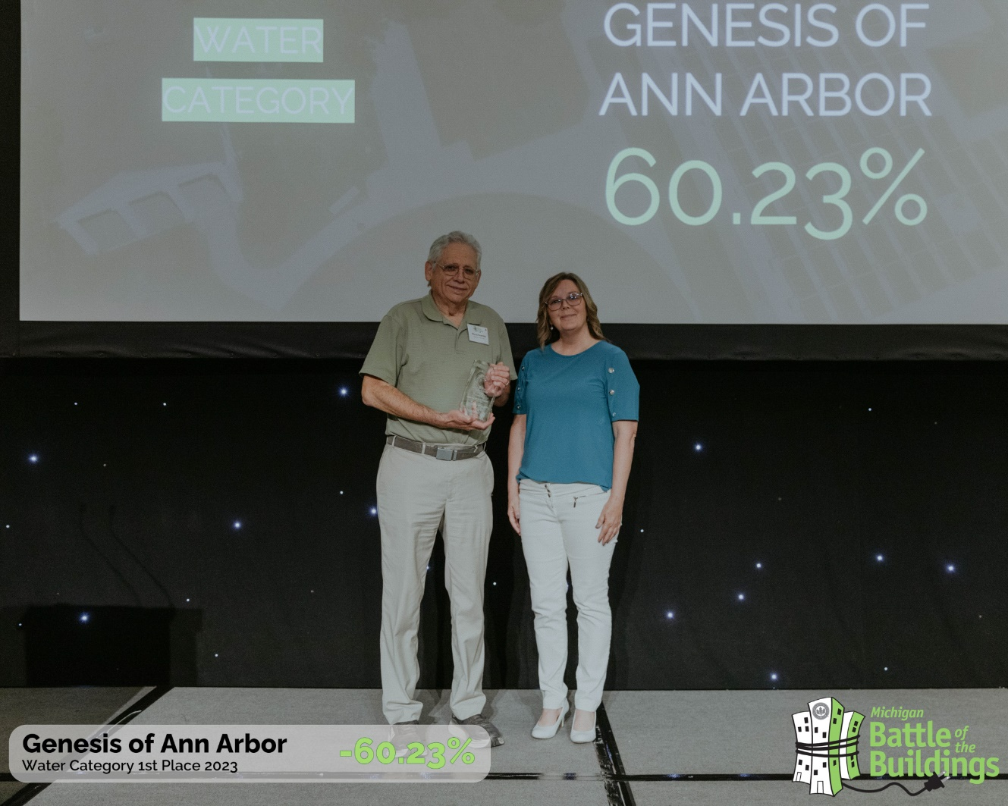

Photo Credit: USGBC Michigan

By Murray Rosenthal

Version date: 14-MAY-2024

